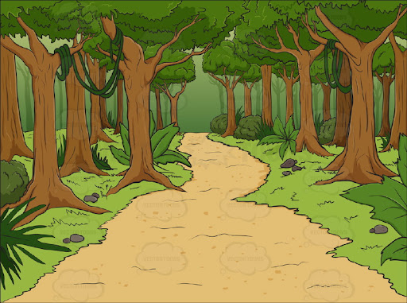

**We will be asking children to Nursery dressed up as a character for our**

**‘Once upon a time day’**

**more details to follow.**

**Nursery Spring 1 Knowledge Organiser**

**Traditional Tales**

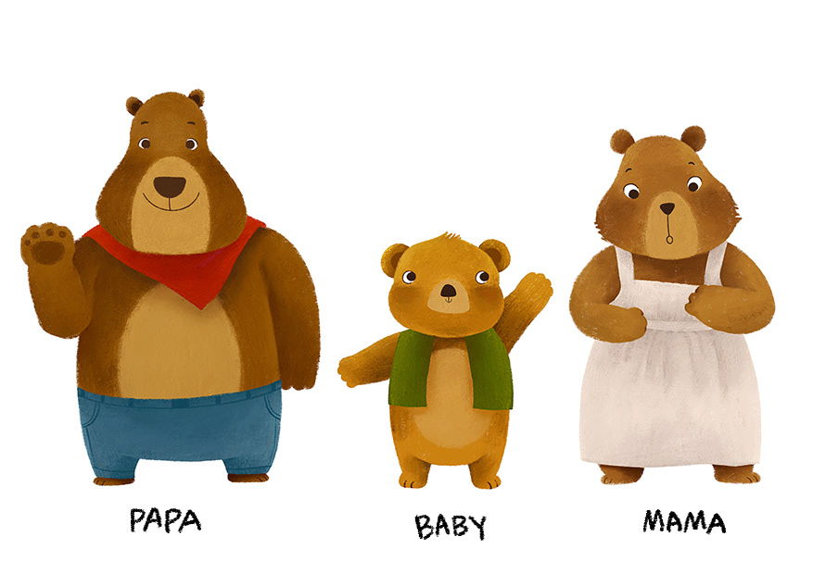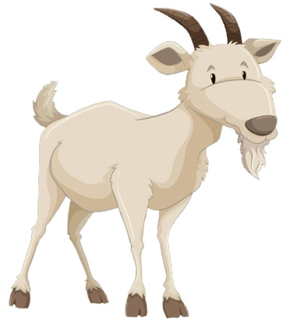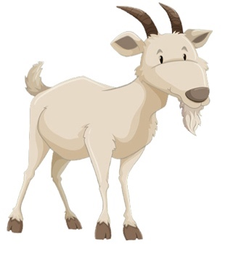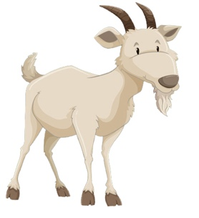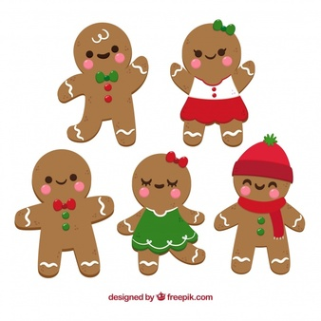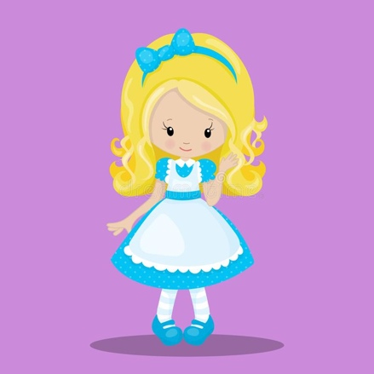

**In Literacy ………**

**We will be doing lots of mark-making with purpose for example writing our name and becoming more confident towards holding a pencil in one hand a tripod grasp**

**We are learning to look at the ilistrations and make predictions to help us find out about the characters and events in a story**

**Key words for our topic:**

**positional language traditional predict rhyme ilistration**

**In Phonics ……….**

**We are learning about rhyming, What is rhyming? Which words rhyme? How do you know?**

**We will also be learning new rhyming songs such as:**

**‘Miss Polly had a Dolly’.**

**In Maths ……….**

**We will continue working on recognising numerals that we see all around us eg on buses, house numbers etc.**

**We will also be learning to use postitional language to describe where an object is eg on top of, under, next to, between, behind etc**

**Books for the term:**

**\*The Gingerbread Man**

**\*Goldilocks and the three bears**

**\*The Billy Goats Gruff**