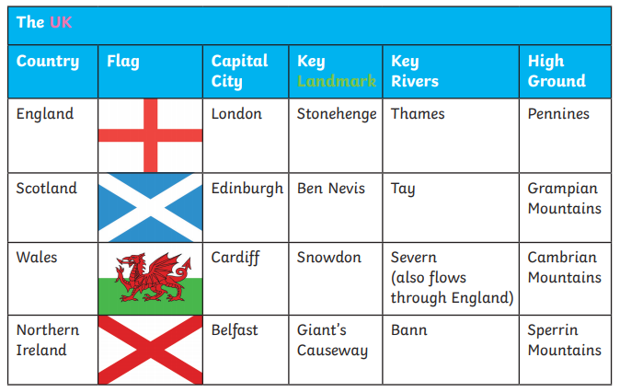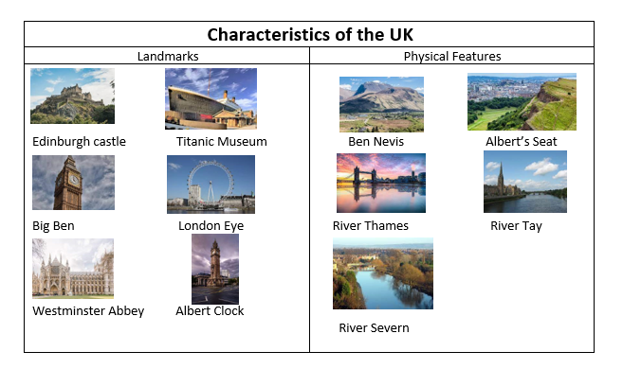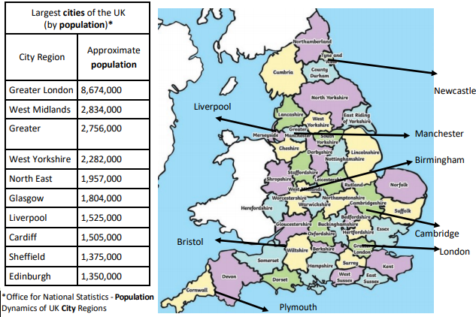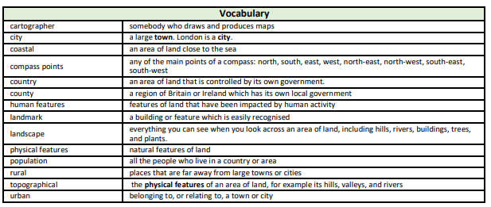

Focus: Why might people move to the UK?

Newall Green Primary School: Knowledge Organiser

Geography: Capital cities in the UK Term: Summer 1

Year group: **5** Date: April 2022

What I should already know:

* Where their local area of Wythenshawe is situated and what its city is called.
* Name local parks and amenities.
* The four countries that make up the United Kingdom and their characteristics.
* The different cities in the UK.
* The terms urban and rural and use them to describe areas of the UK.
* How to locate places using four figure grid references.
* How to identify features such as hills, mountains, coasts and rivers on a map.

Key facts to retain:

* The capital cities of the four countries that make up the United Kingdom and their characteristics.
* The surrounding seas of the United Kingdom.
* The difference between a county and a city.
* What makes a city.
* Famous UK landmarks.
* The flags of the four major capital cities of the UK.
* Different festivals each capital city celebrates.