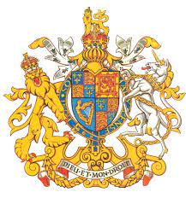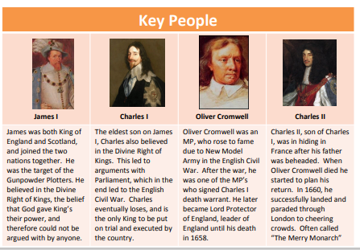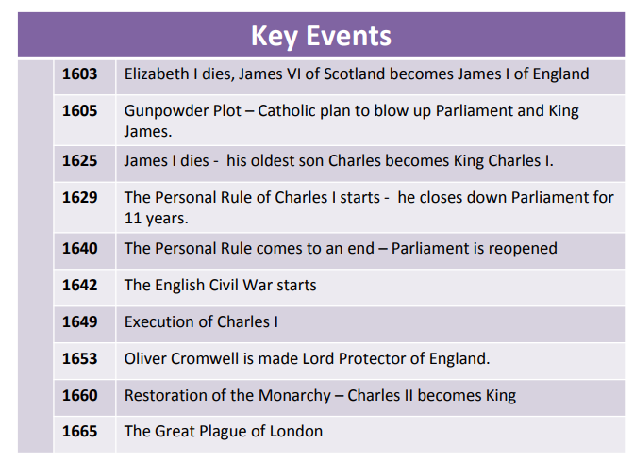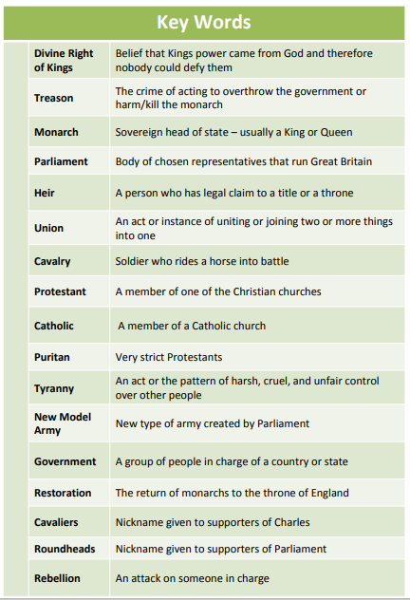

Key facts to retain:

* How the monarchy changed.
* The causes and effects of the Gunpowder plot.
* How the Civil War started, the causes and some of the battles.
* Why the Mayflower is an important part of history.
* Why Charles I thought he was a supreme ruler.
* Why Charles I was executed.

What I should already know:

* Other famous monarchs e.g. Henry VIII, Queen Elizabeth I.
* Key events which have happened in History e.g. Gunpowder plot, World War II, Great Fire of London, Spanish Armada.
* Different British civilisations.
* How people lived during different historical times.

Newall Green Primary School: Knowledge Organiser

History: The Stuarts Term: Summer 1 Year group: **5** Date: Ap 2022

Focus: Was England right in executing the King?