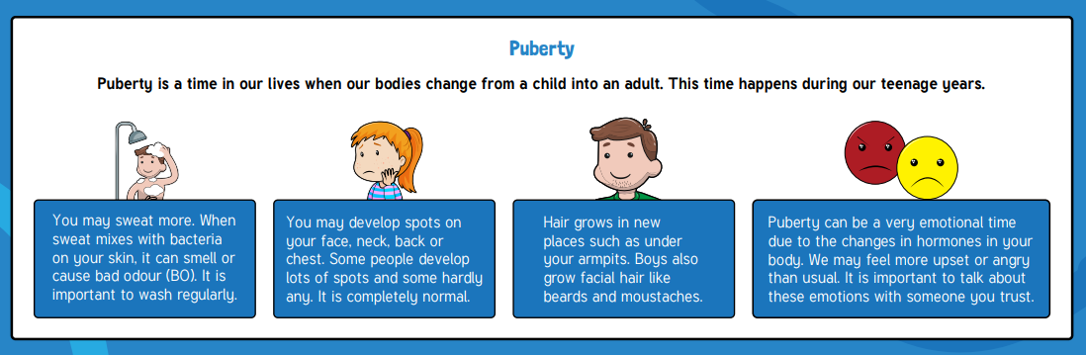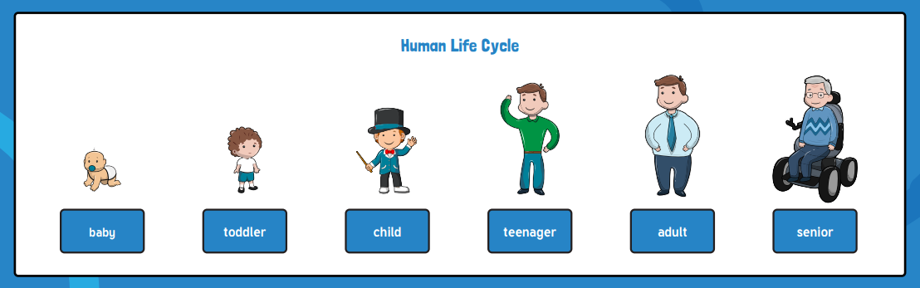

What I should already know:

* Birth and death are the start and end stages of the human life cycle.
* The different parts of a life cycle
* The meaning of a life cycle
* The definition of a living thing
* What living things need to stay alive
* The different parts of the human body

Key facts to retain:

* Fertilisation happens when a male sex cell and a female sex cell combine and begin to grow into a foetus.
* Women have a special organ called a womb which they grow the foetus in until the baby is ready to be born.
* Human babies develop for 9 months in the womb.
* To remember the different stages and what happens at each stage of the human life cycle.
* What puberty is and the different changes boys and girls go through.

Key vocabulary:

Birth - when your life starts as a physically separate being

Conception - when the egg and the sperm meet to begin the development of a foetus

Death - when the life cycle ends

Develop - to grow to become more mature or advanced

Egg - the female sex cell

Fertilisation - when the egg and the sperm meet to begin the development of a foetus

Foetus - a baby that is still developing in the womb

Puberty - a time in the human life cycle when the body goes through changes to become an adult

Sperm - the male sex cell

Womb - an organ in which the foetus grows and develops

Gestation – the process of time when prenatal development takes place before birth

Life cycle – the changes a living thing goes through, including reproduction

Focus: The Human Life Cycle

Newall Green Primary School: Knowledge Organiser

Science: The Human Life Cycle Year 5: Term: Summer 1

Supporting experiences:

PSHE/Dimension lessons