 Nursery Weekly Plan of work based around ‘**Humpty Dumpty’**. 

|  |  |  |  |  |  |
| --- | --- | --- | --- | --- | --- |
| **Before lunch** | **Monday 5th October** | **Tuesday 6th October** | **Wednesday 7th October** | **Thursday 8th October** | **Friday 9th October** |
| **Let’s be nice and kind!** | **Let’s make marks!** | **Let’s listen to sounds!** | **Let’s work on 2D Shapes!** | **Let’s listen to sounds!** |
| **Today is National Be Nice Day** **(5th October)**  **Listen to & watch the**  ‘**Be kind to everyone’** song using this link: <https://www.youtube.com/watch?v=KKSUsS-NoRY>  Ask: Can you think **of a way you are nice and kind?**  Have a nice day — Stock Photo © wenpei #65841275 | **Listen to & watch the**  ‘**Humpty Dumpty’** song using this link: <https://www.youtube.com/watch?v=9fExzr4oa7w>  Ask: Why do you think Humpty Dumpty fell off the wall?  Using the special paper **can you draw Humpty Dumpty sat on his wall? Can you draw his body? Draw him some legs, eyes a smiling mouth?**  **Can you write your name?** | **Going on a Listening Walk -**  Sit with your child in a quiet part of your house and listen quietly for sounds around you. Ask your child: **What can you hear?** Give them time to think. Next go on a walk around your house and listen for sounds. What can we hear inside? Share ideas about what you have heard. | Repeat the **Shape Hunt** around your house or in your garden. Talk about the shapes you find.  Using the special paper **can you draw a picture of something you found on your shape hunt? Eg a circle clock, a rectangle table etc**  **Can you write your name?** | **Going on a Listening Walk -**  Sit with your child in a quiet part of your house and listen quietly for sounds around you. Ask your child:  **What can you hear?**  Can they hear more things this time than last time? Are they listening more today? |
| Let’s have snack time! Do something nice for your grown up | | | | |
| **Let’s be kind!** | **Let’s make marks!** | **Let’s be Peaceful!** | **Let’s make marks!** | **Let’s get physical!** |
| Have a little think about how you have been **nice and kind today?**  Using the special paper **can you draw a picture of you being a nice and kind person?**  **Can you write your name?** | **Sing Humpty Dumpty and try to wave your arms slowly to the song**  Choose one of the Humpty dumpty pencil control activity sheets to try. Remember to hold your pencil correctly. | On You Tube Search:Peace Out Guided Relaxation for Kids | 6. Butterfly using this link: <https://www.youtube.com/watch?v=Uy5YgQe1o3Q> **Enjoy feeling quiet and calm.**  /var/folders/3x/qzk7csx122q3l7w7g6njfz9c0000gn/T/com.microsoft.Word/WebArchiveCopyPasteTempFiles/hqdefault.jpg?sqp=-oaymwEiCKgBEF5IWvKriqkDFQgBFQAAAAAYASUAAMhCPQCAokN4AQ==&rs=AOn4CLCATgqDqu2T4FFSiKr0WR1AK67n5Q | **Sing Humpty Dumpty and try to clap your hands slowly to the song**  Choose one of the Humpty dumpty pencil control activity sheets to try. Remember to hold your pencil correctly. | On You Tube search:‘Open Shut Them’ song using this link: https://www.youtube.com/watch?v=9LbZSyx-7XoCan you move and dance to the music?/var/folders/3x/qzk7csx122q3l7w7g6njfz9c0000gn/T/com.microsoft.Word/Content.MSO/99BD8BAD.tmp |

 Nursery Weekly Plan of work based around ‘**Humpty Dumpty’**. 

|  |  |  |  |  |  |
| --- | --- | --- | --- | --- | --- |
| **After lunch** | **Monday 5th October** | **Tuesday 6th October** | **Wednesday 7th October** | **Thursday 8th October** | **Friday 9th October** |
| **Let’s be Peaceful!** | **Let’s be nice and kind!** | **Let’s work on 2D Shapes!** | **Let’s get Musical!** | **Let’s make marks!** |
| On You Tube Search:Peace Out Guided Relaxation for Kids | 1. Balloon using this link: <https://www.youtube.com/watch?v=ZBnPlqQFPKs> **Enjoy feeling quiet and calm.**  Peace Out Guided Relaxation for Kids | 1. Balloon - YouTube | **Listen to & watch**  **‘Mr Tumble’s Top 3 Kindness Moments’**  using this link: <https://www.youtube.com/watch?v=_xBTuAkuTBw>  **Can you remember who the surprise party was for?**  **What things did they do at the party? How did super Tumble help Baker Tumble, Shopkeeper Tumble and Aunt Polly?** | Go on a **Shape Hunt** around your house or in your garden. Talk about the shapes you find. Try to draw them too! Can you see any shapes in your kitchen? In your bedroom as you go on your walk today? | **\*Playdough or plasticine needed\*** On You Tube Search:Fine motor development | Playdough song | If you're happy and you know it using this link: <https://www.youtube.com/watch?v=DrBsNhwxzgc>Why? What makes you feel happy? Fine motor development | Playdough song | If you're happy and you ... | On You Tube Search:Learn to count 1-15 Pirate Song using this link: <https://www.youtube.com/watch?v=HPqNys1A3iw> Practice counting your numbers with the pirate.  Next try the Number formation activity sheet Remember to hold your pencil correctly. |
| Let’s have snack time! Say something nice to your grown up | | | | |
| **Let’s be kind!** | **Let’s share a story!** | **Let’s be mindful!** | **Let’s share a story!** | **Let’s share a story!** |
| Talk about how **you have been nice and kind today?** | **Share a story with your grown up.**  **Can you** talk about what happened in the beginning of your story?  Speech All the Time: Is Shared Storybook Reading Evidence Based ... | On You Tube Search:Cosmic kids’ yoga ‘The Listening game’ using this link: [**https://www.youtube.com/watch?v=uUIGKhG_Vq8**](https://www.youtube.com/watch?v=uUIGKhG_Vq8)  Superpower Listening | Cosmic Kids Zen Den - Mindfulness for kids - YouTube | **Share a story with your grown up.**  **Can you** point to where the pictures are in the story?  Speech All the Time: Is Shared Storybook Reading Evidence Based ... | **Share a story with your grown up.**  **Can you** point to wthe writing is in the story?  Speech All the Time: Is Shared Storybook Reading Evidence Based ... |
| Let’s relax and think about our day! What have you enjoyed learning about today? Why did you like it? | | | | | |

Other things to be thinking about each day.

1. 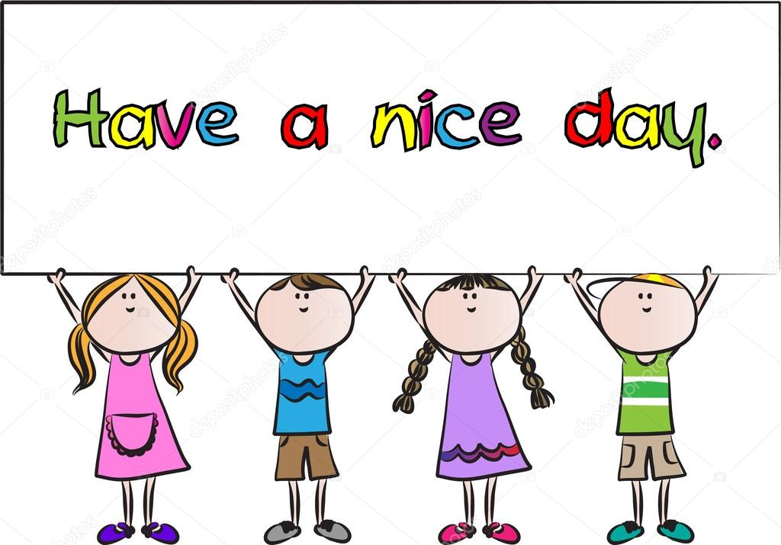 It’s **National Be Nice Day** **(5th October)** Of course, we should be nice to one another every day but on National Be Nice Day let’s all try and think of ways we can be nice, say nice things and do nice things while we are at home.
2.  How do you feel today? It’s important to be mindful of your child’s mental well-being and support them when they aren’t feeling okay. Listen and sing along to this song ‘Feelings are Feelings’ using this link: <https://learnenglishkids.britishcouncil.org/songs/feelings-are-feelings> It’s a useful way to find out how your child is feeling.
3. 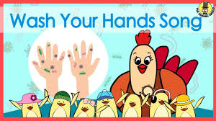 Don’t forget it’s important that your child knows how to wash their hands correctly. Children need to understand why they must wash their hands as well as how to do it. This child friendly song on You tube is a fun way to learn all about the importance of handwashing. Listen and sing along to ‘**Wash Your Hands Song’** using this link: <https://www.youtube.com/watch?v=dDHJW4r3elE>

Enjoy this week’s activities, take care and stay safe from the Nursery Team