3D Shapes Hunt
Walk around your house and look for objects that are 3D shapes. Record your findings in the table below. You can draw pictures or write names of the objects you find.

Shapes to find: cube, cuboid, cone, cylinder, sphere and square-based pyramid.

Cube   | Cuboid  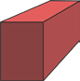 | Cone   | Cylinder   | Sphere   | Pyramid  